SIMATS ENGINEERING

ASSESSMENT TOOL 3

COURSE NAME: Artificial Intelligence COURSE CODE: CSA1707

COURSE OUTCOME COVERED

CO1: Apply AI basics such as intelligent agents and uninformed search methods to solve problems effectively. (BL3)

Assessment Tool Weightage: 30%

Duration : 45 Minutes
QUESTIONS: 2 Total Marks:20

Annexure A

Descriptive Written Test

Code of Conduct:

I s Lakshmi priya (192524284) (Name / Reg No) certify that this submission is my original work and that I have adhered to the guidelines specified for this assessment.
I understand that any violation of academic integrity rules will result in disciplinary action.

Signature of the student:

S priya
Annexure A

Descriptive Written Test

- A smart home automation system is being designed to manage lighting, temperature, and security based on user behavior and environmental conditions. The system must respond to real-time inputs such as motion detection, temperature changes, and time of day while also learning user preferences over time. In this context, explain the different types of intelligent agents (simple reflex, model-based, goal-based, and utility-based agents) and analyze how each type would function within this system. Justify which type of agent or hybrid approach would be most effective for ensuring comfort, energy efficiency, and security.

Smart Home Automation: Types of Intelligent Agents

PEAS of the smart home
- Performance: user comfort, low energy use, security, fast response
- Environment: home with occupants, changing temperature, light levels, time of day
- Actuators: lights, thermostat/AC/heater, door locks, alarm, cameras, notifications
- Sensors: motion, temperature, light, door/window contacts, clock, cameras, user app input
The environment is partially observable (the system cannot see inside every room or know occupants' intentions), stochastic, sequential, dynamic and continuous.

1. Simple reflex agent
Chooses an action from the current percept only, using condition-action rules. It has no memory and no model.
In the smart home:
- IF motion detected AND room dark → turn on light
- IF temperature > 30°C → switch on AC
- IF door opened while alarm armed → sound alarm
- IF smoke detected → unlock doors and alert
Strengths: very fast, simple and reliable. It is ideal for safety-critical instant responses.
Weaknesses:
- Lights stay on in an empty room, because it cannot tell that nobody is there any more.
- It cannot tell a resident from an intruder.
- It reacts to a brief temperature spike with no sense of trend.
- It cannot learn preferences.

2. Model-based reflex agent
Keeps an internal state (a model of the world) built from percept history, and how its own actions change the world.
In the smart home:
- Tracks which rooms are occupied, using the sequence of motion events, and turns lights off after the room has been empty for several minutes.
- Remembers that the AC was switched on and that the temperature is falling, so it avoids over-cooling.
- Knows whether the house is in "home", "away" or "night" mode, and whether a door was left open.
- Infers occupancy even when a person sits still and the motion sensor reports nothing.
Strengths: handles partial observability and avoids silly reactions.
Weaknesses: still follows rules. It does not weigh trade-offs or plan ahead.

3. Goal-based agent
Has explicit goals and chooses actions by considering whether they will achieve them. It uses search and planning.
In the smart home:
- Goal: "room at 22°C by 7 pm when the user returns". The agent plans when to start the AC, based on the current temperature and how long cooling takes.
- Goal: "house secured by 11 pm". The agent plans the steps: check windows, lock doors, arm the alarm, switch off unused lights.
- Goal: "make the house comfortable for movie night". It sequences dimming lights, closing blinds and setting temperature.
Strengths: flexible, because changing the goal changes the behaviour without rewriting rules. It handles multi-step tasks.
Weaknesses: a goal is yes or no. It cannot rank two ways of reaching the goal (a fast, costly one versus a slow, cheap one), and it cannot resolve conflicts between goals.

4. Utility-based agent
Uses a utility function to measure how desirable each state is, and picks the action with the highest expected utility. This handles trade-offs and uncertainty.
In the smart home:
- Utility = w1 × comfort − w2 × energy cost − w3 × security risk.
- Cooling the house early is comfortable but costly, so the agent picks a start time that maximizes the overall trade-off, for example pre-cooling during cheaper tariff hours.
- If comfort and energy conflict (the user is away but may return soon), it chooses the option with the best expected value.
- Under uncertainty (is that motion a resident or a stranger?), it weighs the cost of a false alarm against the cost of a missed intrusion.
Strengths: the most rational type. It balances competing objectives and handles uncertainty.
Weaknesses: needs a well-designed utility function and more computation.

Learning component (for all types)
The system must learn preferences over time. A learning agent adds:
- Critic: compares results with the performance measure (the user manually overrides the thermostat, so the action was wrong).
- Learning element: updates rules, goals or utility weights (learns the user prefers 24°C in the evening).
- Performance element: the existing agent that selects actions.
- Problem generator: tries small experiments (a slightly lower temperature) to discover better settings.

Comparison
Agent | Uses memory | Plans ahead | Handles trade-offs | Learns | Smart home use
Simple reflex | No | No | No | No | Instant safety responses
Model-based | Yes | No | No | No | Occupancy and mode tracking
Goal-based | Yes | Yes | No | No | Scheduled comfort and security routines
Utility-based | Yes | Yes | Yes | Optional | Balancing comfort, energy, security

Best choice: a hybrid, layered, learning agent
No single type is enough. The most effective design is a hybrid architecture with a utility-based core and a learning component:
- Reflex layer (fastest, highest priority): simple reflex rules for emergencies such as smoke, forced entry or gas leak. These must respond in milliseconds and override everything else.
- Model layer: a model-based state tracker maintaining occupancy, room states, device status and the home mode. It supplies the context for every higher decision.
- Goal layer: goal-based planning for routines (arrive home comfortable, secure the house at night, wake-up lighting).
- Utility layer: a utility-based decision maker that picks among the ways to meet goals by trading off comfort, energy cost and security risk.
- Learning layer: learns user habits and updates utility weights and schedules from overrides and feedback.

Why this is most effective
- Comfort: the model and learning layers anticipate preferences and adjust lights and temperature before the user asks.
- Energy efficiency: the utility layer avoids wasteful actions, such as heating empty rooms, and uses cheaper tariff periods.
- Security: reflex rules guarantee an instant response to threats, and the model layer distinguishes a normal pattern from an unusual one.
- Real-time response plus long-term learning: reflex and model layers handle the moment, while goal, utility and learning layers improve behaviour over time.
- Safety first: the reflex layer overrides the utility layer, so an energy-saving decision can never delay an emergency response.
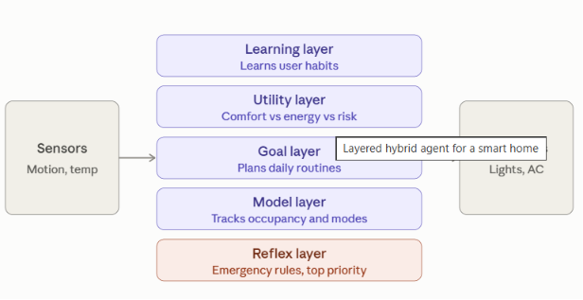
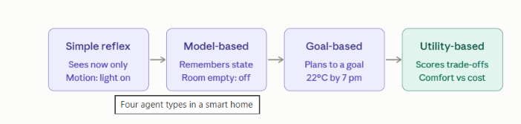
Reading the two diagrams together: the four agent types in the second one are the building blocks, and the first one shows how they are combined. In the layered diagram, the red reflex layer sits at the bottom with top priority, so emergency rules always override the layers above it. The learning layer on top keeps updating the other layers from user overrides.

Conclusion: simple reflex agents give speed, model-based agents give context, goal-based agents give planning, and utility-based agents give optimal trade-offs. Combining them in a layered, learning architecture is the most effective way to deliver comfort, energy efficiency and security together.

- A robot is placed in an unknown maze and must find a path to the exit without prior knowledge of the layout. Explain how uninformed search strategies like Uniform Cost Search (UCS) and Iterative Deepening Search (IDS) can help solve this problem.
Discuss the advantages and disadvantages of these algorithms in terms of time and space complexity. Relate the problem to different types of intelligent agents and explain how agent design affects decision-making. Suggest which combination of agent type and search strategy would be most effective and justify your choice.

Unknown Maze: UCS, IDS and Agent Design

1. How the two strategies help
The maze is a graph. Each cell is a state, moves (up, down, left, right) are actions, and the exit is the goal test. Because the robot has no heuristic or map, it can only use uninformed search.
Uniform Cost Search (UCS)
- Keeps a priority queue ordered by path cost g(n) and always expands the cheapest node first.
- It handles unequal move costs (mud, slopes, narrow turns) and returns the cheapest route, not just the shortest in steps.
- With equal step costs it behaves like BFS, expanding the maze in rings around the start.
Iterative Deepening Search (IDS)
- Runs depth-limited DFS with limit 0, then 1, then 2, and so on until the exit is found.
- It gets BFS's guarantee (the shallowest exit is found first) with DFS's tiny memory.
- The repeated work is small, because most nodes are at the deepest level. For b = 10 and d = 5, IDS generates about 123,450 nodes against 111,110 for BFS, an overhead of roughly 11%.

2. Time and space complexity
b = branching factor (at most 3 in a maze, since the robot rarely goes back), d = depth of the shallowest exit, C* = optimal cost, ε = minimum step cost.
 | UCS | IDS
Complete | Yes, if every step cost is at least ε > 0 | Yes, if b is finite
Optimal | Yes (least cost) | Only for equal step costs (shallowest = cheapest)
Time | O(b^(1+⌊C*/ε⌋)) | O(b^d)
Space | O(b^(1+⌊C*/ε⌋)), exponential | O(b·d), linear
 | Advantages | Disadvantages
UCS | Optimal with varying costs; no depth guess needed | Memory grows exponentially and is the real bottleneck; explores in all directions, with no sense of where the exit is; can be slow if many tiny-cost steps exist
IDS | Very low memory; complete; finds the shallowest exit | Ignores costs, so it can return an expensive path; repeats work at shallow levels; no heuristic guidance
Both are blind to the exit's direction, so in a large maze they expand far more nodes than an informed method such as A*.

3. A caveat: the maze is unknown
UCS and IDS assume the agent can try paths in simulation. A robot in an unknown maze can't: it sees only nearby cells, and "restarting from the start" means physically driving back. So the search runs on the map the robot builds as it goes. The cycle is sense, update the map, search the known part, move, repeat (online search). IDS suits the exploration phase because of its small memory. UCS suits planning once the map has costs.

Agent types and decision-making

Agent | How it behaves in the maze | Limitation
Simple reflex | Rules such as "follow the left wall" or "turn if blocked" | No memory, so it can loop forever in a maze with cycles, and its path is far from optimal
Model-based reflex | Keeps a map and a visited set, so it can avoid loops and dead ends | Still reacts to rules and does not plan the route
Goal-based | Has the explicit goal "reach the exit" and plans a path through the known map (search lives here) | Treats all successful paths as equal
Utility-based | Scores paths by time, energy, risk and terrain, and picks the best trade-off | Needs a good utility function and more computation
Learning | Improves its map, cost estimates and strategy from experience | Needs time to learn and may make errors early
Agent design decides what the robot can even do. A simple reflex agent can't use UCS or IDS at all, because it has no state to search. A model-based agent has the map but no planning. Search needs at least a goal-based, model-based design.

5. Recommended combination
A model-based, goal-based agent that is utility-driven, using UCS for planning and IDS-style exploration:
- Model: build a map of visited cells, walls and move costs from sensor data. This copes with partial observability and prevents loops.
- Goal: reach the exit.
- Exploration (IDS style): when the exit is not yet known, explore with increasing depth limits. Memory stays at O(b·d), which suits an onboard computer, and the nearest unexplored area is checked first.
- Planning (UCS): once part of the map is known and costs differ, use UCS to find the cheapest route to the exit, or to the nearest frontier cell.
- Re-plan whenever new walls or hazards appear.

Why this combination
- Handles the unknown layout: the map and re-planning loop make up for having no prior knowledge.
- Complete and optimal where it matters: IDS guarantees the exit is found if it exists, and UCS guarantees the cheapest route on what is known.
- Memory-safe: IDS avoids UCS's exponential memory during open-ended exploration.
- Cost-aware: the utility view (time, energy, risk) lets the robot avoid expensive or dangerous cells, which IDS alone ignores.
- Not the simple alternatives: a reflex wall-follower can loop, UCS alone can exhaust memory, and IDS alone ignores costs.
Practical note: if every move costs 1, UCS reduces to BFS and IDS is the better choice because of memory. If costs vary, use UCS. For a real deployment, replace both with an informed method such as A* or D* Lite once a heuristic such as Manhattan distance is available.

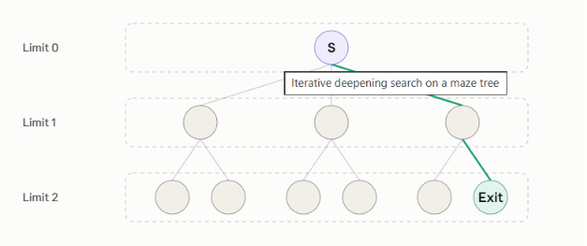

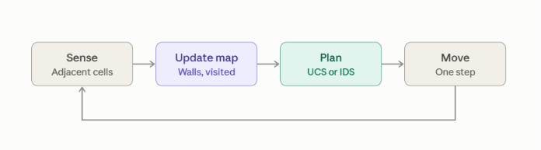

The loop is what makes the robot a model-based, goal-based agent. The map is its internal state, the planner (UCS for cost, IDS for low memory) is the goal-based part, and the return arrow is the re-planning after every step. A simple reflex agent would have only the Sense and Move boxes, with no map and no planning in between.

RUBRICS FOR CALCULATION:

Criteria | Weightag e | Level 4 – Exemplary | Level 3 – Proficient | Level 2 – Developing | Level 1 – Beginnin g
Criteria | Level 4 (Exemplary) | Level 3 (Proficient) | Level 2 (Developing) | Level 1 (Beginning) | Max Marks
Understanding of Concepts | 25% | Demonstrates thorough, accurate understanding of concepts | Good understanding with minor gaps | Basic understanding with some misconception s | Poor understandi ng; major misconcepti ons
Explanation | 25% | Detailed,  well-explained answers with relevant examples | Clear explanation with adequate details | Limited explanation; lacks depth | Poor or unclear explanation
Application | 20% | Effectively applies concepts with strong analytical ability | Applies concepts with minor errors | Limited application with weak analysis | No application or incorrect analysis
Organization | 15% | Well-structure d answers with logical flow and coherence | Organized with minor issues in flow | Basic structure, lacks clarity | Poor organizatio n, incoherent answers
Accuracy | 10% | Completely accurate and covers all required points | Mostly accurate with minor omissions | Partially correct with missing points | Incorrect answers with major gaps
Clarity | 5% | Clear, neat, professional presentation | Understandable with minor issues | Limited clarity, readability issues | Poorly written, difficult to understan d

